1. Spring_app_Pipeline configuration:

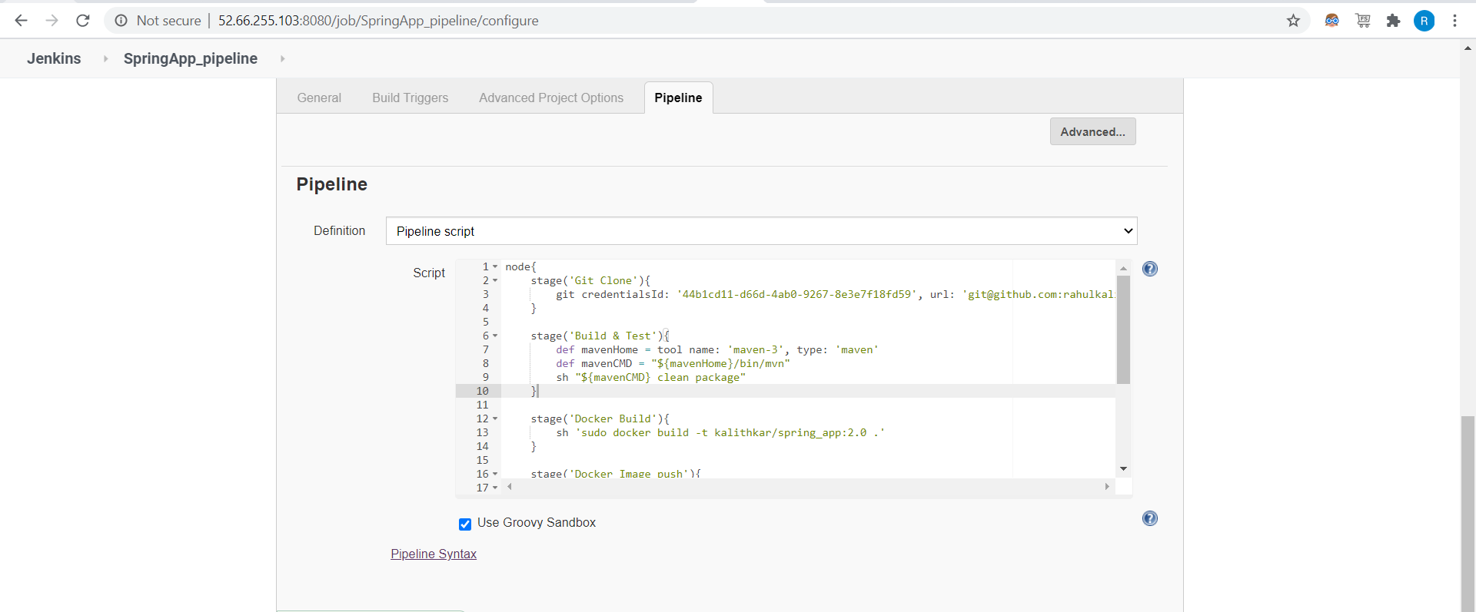

1. Pipeline job success:

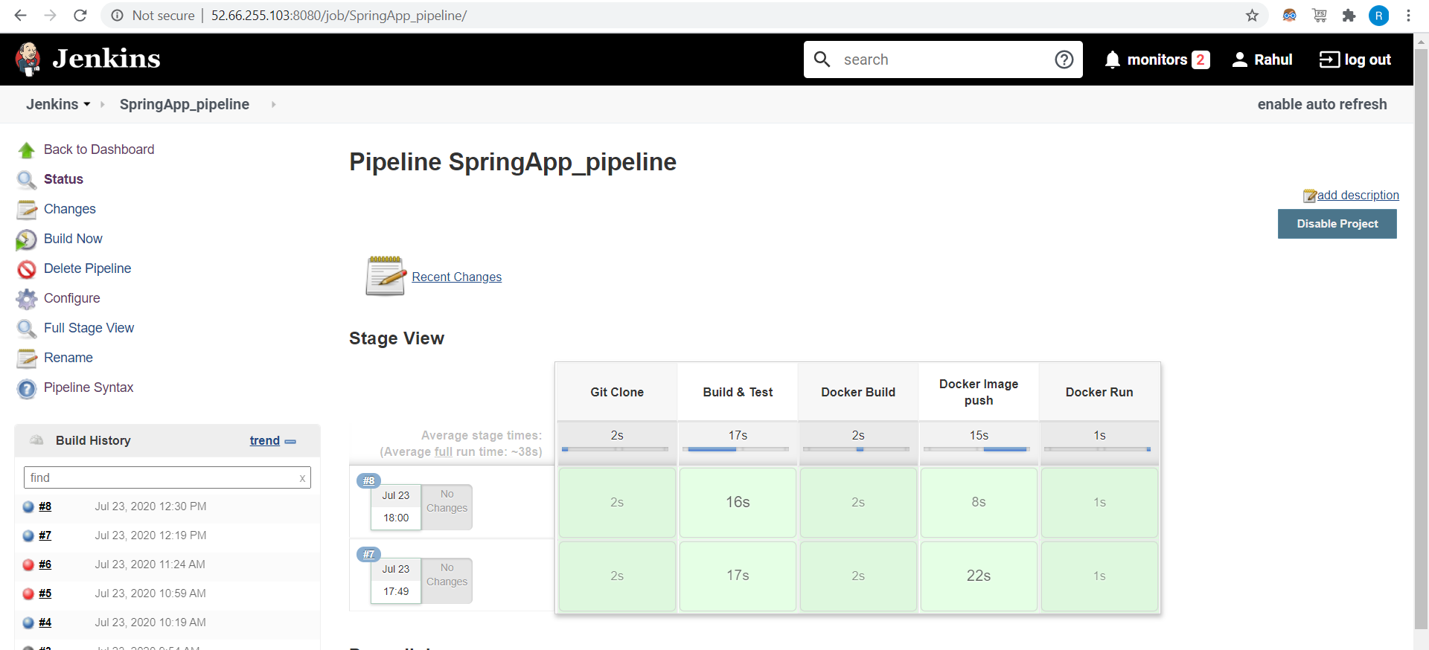

1. Docker container is running from ec2 instance:

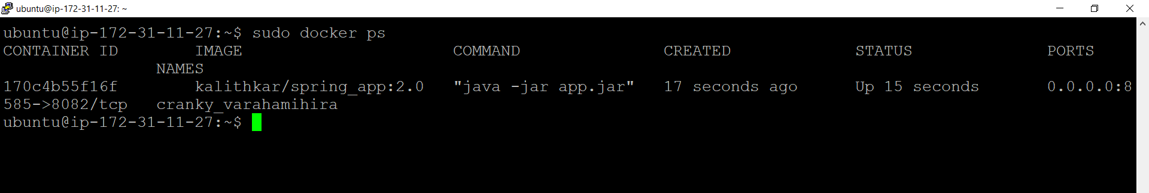

1. Application accessing from localhost:



1. webApp_Pipeline configuration:

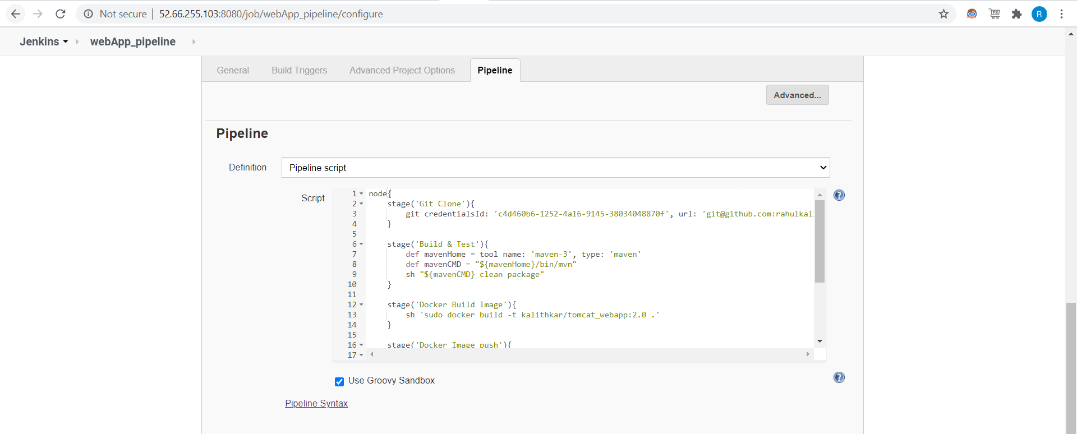

1. Pipeline job success:

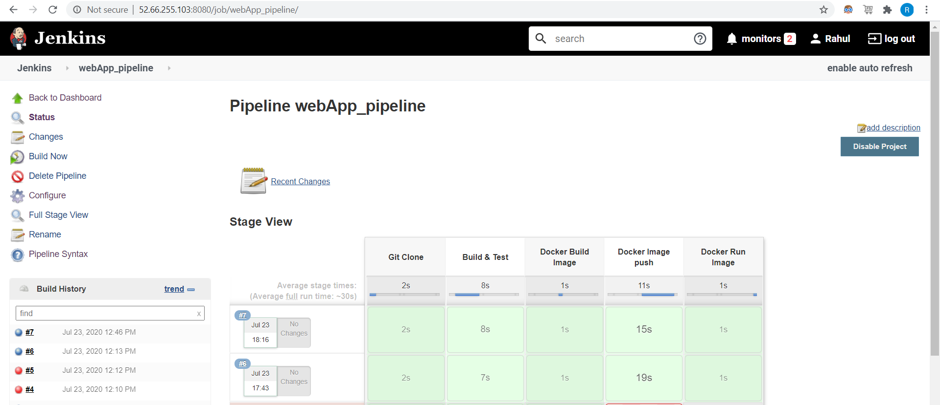

1. Docker container is running from ec2 instance: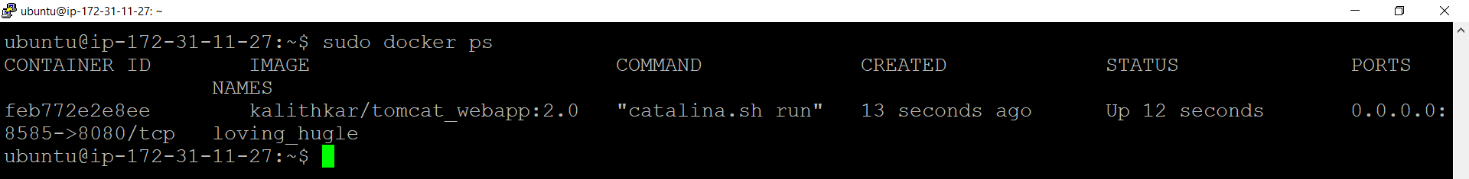
2. Application accessing from localhost:



1. Docker images pushed to repo:

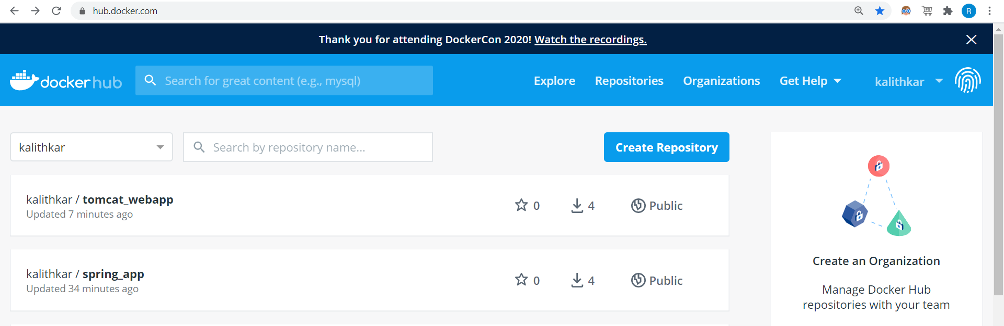

1. Pushing the docker image to PCF

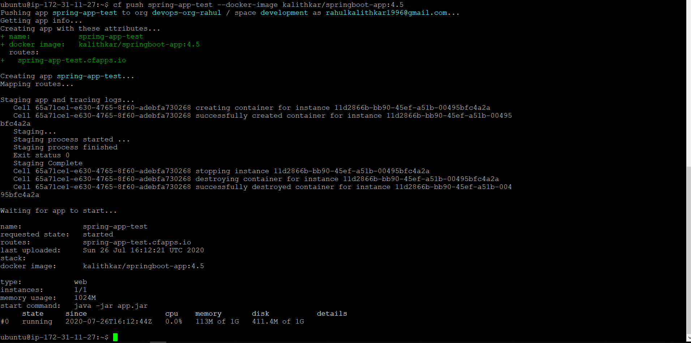

1. Run on Cloud Foundary

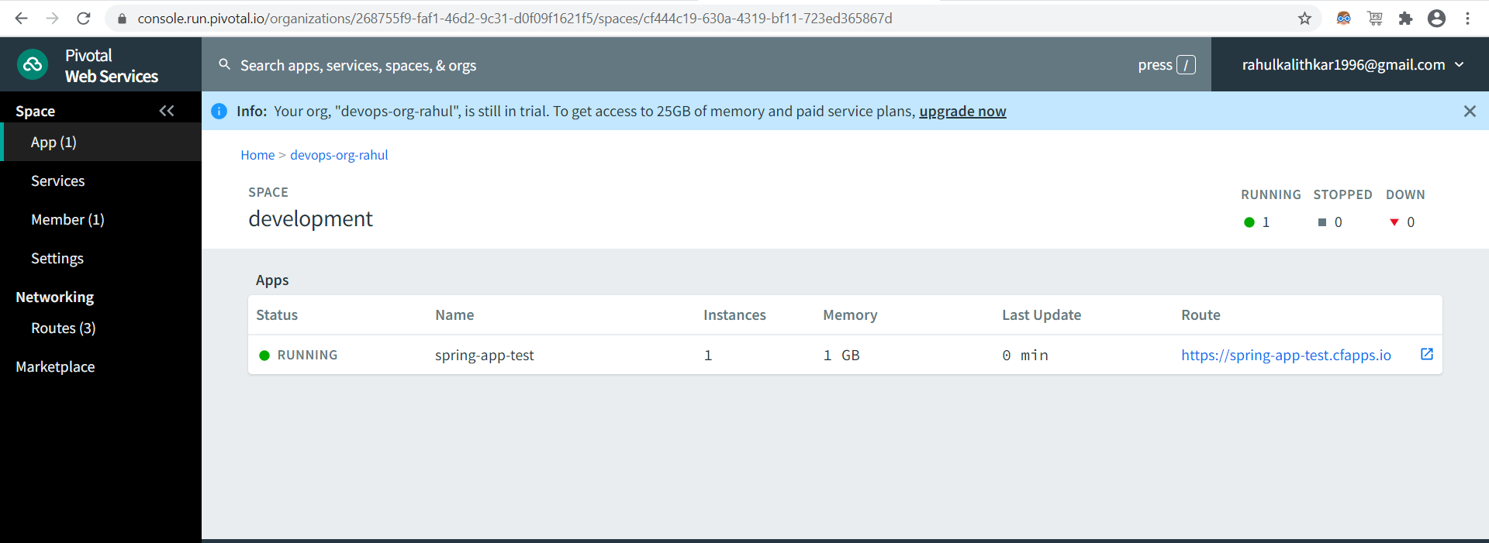

1. Routing to application to web

